Set Header Step

Objective:

Initialization is the assignment of an initial value for a data object or variable. The manner in which initialization is performed depends on the programming language, as well as type, storage class, etc., of an object to be initialized.

Set key-value pair in the response header.

UI

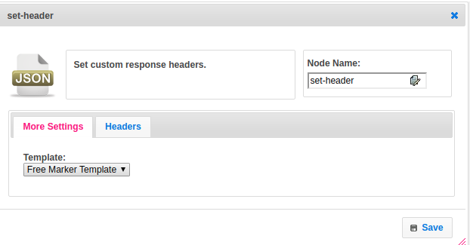

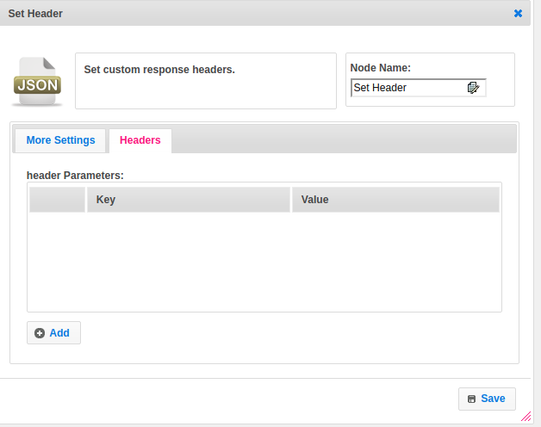

## Attributes

|  |  |
| --- | --- |
| **Attributes** | **Description** |
| **1. Template** | The template used to set the value type.  Value types are two types.  1.hb-HandleBars  2.ftl-Freemarker Template Language. |
| **2. Header** | The header contains a list of maps. |

## Executor Description

Get the header list and iterate the list setHeader of HttpResponse class by passing the key and value pair.